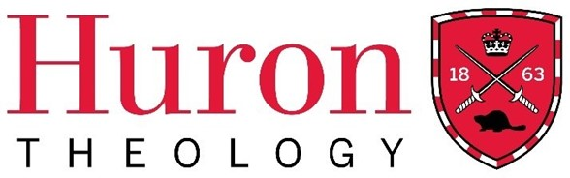

Fall Term 2025

Theological Studies 310
Our Anglican Family Tree:
The Anglican Communion and Ecumenical Relationships
Huron’s Licentiate in Theology Program

Huron University College Land Acknowledgment

Huron is situated on the traditional lands of the Anishinaabeg, Haudenosaunee, Attawandaron, and Lenape peoples, whose sharing and stewardship of the land has been governed by the Dish with One Spoon treaty since time immemorial. We are guided by this treaty in the spirit of peace, friendship, and respect. Huron University College acknowledges its past role in perpetuating colonial and exclusionary relations. Because religious and ecclesial institutions were instrumental in such relations, we consider it our particular responsibility as a Faculty of Theology to work towards justice and reconciliation.

Course Dates: September 9th – October 28th, 2025. Note: no class on Oct. 7th & 21st.
Time: Tuesday from 7 – 9 P.M. (CT); 8 – 10 P.M. (ET)
Delivery: Hosted via Zoom
Instructor: The Most Reverend Linda Nicholls, DMin, DD

Contact: bplinda18@gmail.com Phone: (519) 636-7951

Ecumenism – An Exploration of history and practice

‘That they may be one ….’ (John 17:21) was part of Jesus’ prayer for the disciples. Yet our witness in the world continues to be marred by the divisions amongst Christians. As well, in recent years, the challenges facing our parishes have invited us to look to our neighbouring churches to share buildings, engage in ministry together, and in some cases, worship together. We often know little about each other! This will be a course for those preparing for leadership in the church – lay or ordained – to explore the necessity, gifts and challenges of ecumenical encounters with attention paid to Anglican engagement in ecumenical dialogue and movements.
Course Description
This six-week course will begin with a look at the roots of division of the church in a brief historical overview and then focus on efforts towards Christian unity; methods of ecumenical engagement and specifically Anglican ecumenical engagements at the local, national and international levels. The course will engage participants in reflection on ecumenical efforts in their own context and the gifts of ecumenical work for the future.

Course Outline

Content will include a brief history of ecumenical division; movements in ecumenism with a focus on the 19th-21st centuries; methods of ecumenical engagement; current ecumenical challenges; and ecumenism in practice for ministry.

Week #1:
September 9: Introduction to the Course & Introduction to Ecumenism: How did we get here?
(Overview) & Division in the Christian Church - When did it start? Why?
Historical overview – Jesus to 1400

Week #2:
September 16: Historical overview 1400 to present - Continued

Week #3:
September 23: Movements for Christian Unity – signs; voices; biblical witness;

Week #4:
September 30: Methods of Ecumenical Engagement
Methods of Ecumenical Engagement –

Week #5:
October 14: Full Communion - What is it? With whom? Anglican Covenants

Week #6: October 28: Anglican Engagement – local, Canada, Anglican Communion – shared ministry agreements (Anglican/Lutheran; Anglican/United); Dialogues

Required Readings (Note: *** are assigned readings)
World Council of Churches:
***Baptism, Eucharist and Ministry 1982 https://www.oikoumene.org/resources/documents/baptism-eucharist-and-ministry-faith-and-order-paper-no-111-the-lima-text
***The Church Towards a Common Vision 2013 https://www.oikoumene.org/resources/documents/the-church-towards-a-common-vision
ARCIC I - Final Report: https://www.christianunity.va/content/unitacristiani/en/dialoghi/sezione-occidentale/comunione-anglicana/dialogo/arcic-i/testo-in-inglese.html
Joint Working Group between the Roman Catholic Church and the WCC:
Reception: A Key to Ecumenical Progress 2014 https://www.christianunity.va/content/dam/unitacristiani/Relazioni%20ecumeniche/Sezione%20occidentale/Dialogo%20multilaterale/COE/JWG/Documents/EN%20Reception%20Key.pdf
Rusch, William G. Ecumenical Reception: Its Challenge and Opportunity (Wm B Eerdmans Publishing Company, Grand Rapids, 2007)
***The Waterloo Declaration (Evangelical Lutheran Church in Canada & Anglican Church of Canada)
https://www.anglican.ca/faith/eir/full-communion-partnership/waterloo/
The Anglican United full communion conversation – 1960’s-70’s – Why did it fail?
*** Anglican United shared ministries – stories: https://www.anglican.ca/wp-content/uploads/Sharing-Ministry-Ecumenically.pdf
***Anglican Moravian Full Communion - 2023 – https://www.anglicanlutheran.ca/wp-content/uploads/Lutheran-Anglican-Moravian-LAM-Declaration.pdf
Future of Ecumenism Article: https://www.logos.com/grow/nook-ecumenism-history/
***New Stories to Tell – Anglican & RC Ecumenical Reflections: https://iarccum.org/archive/Canada/2018_ARC-Canada_New-Stories-to-Tell_en.pdf

Method of Evaluation and Criteria for Grading (only for students choosing to be evaluated for full course credit)

Assignments and Evaluation

- 20% Assigned Readings; participation in discussion
  - Two reflections on any two of the readings (250 words)

- 30% One paper – 2-3 pages (500-750 words, double spaced) - Reflection paper on personal visit to worship with a denomination other than your own – in the spirit of the practice of receptive ecumenism
- 20% Quiz in class

- 30% One exam – to be completed at home and submitted no later than two weeks after the end of the classes

Huron Grade Descriptors
A+ | 90-100 | One could scarcely expect better from a student at this level
A | 80-89 | Superior work which is clearly above average
B | 70-79 | Good work, meeting all requirements, and eminently satisfactory
C | 60-69 | Competent work, meeting requirements
D | 50-59 | Fair work, minimally acceptable
F | below 50 | Fail

Student Code of Conduct
Membership in the community of Huron University College and Western University implies acceptance by every student of the principle of respect for the rights, responsibilities, dignity and well-being of others and a readiness to support an environment conducive to the intellectual and personal growth of all who study, work, and live within it. Upon registration, students assume the responsibilities that such registration entails. While in the physical or online classroom, students are expected to behave in a manner that supports the learning environment of others. Please review the Student Code of Conduct at: https://huronatwestern.ca/sites/default/files/Res%20Life/Student%20Code%20of%20Conduct%20-%20Revised%20September%202019.pdf.

Statement on the Recording of Class Activities
Students may not record or distribute any class activity, including conversations during office hours, without written permission from the instructor, except as necessary as part of approved accommodations for students with disabilities. Any approved recordings may only be used for the student’s own private use.

Online courses within the Licentiate in Theology Program are recorded for student engagement purposes. These recording are only used by the registered students of the class and made available through a restricted video hosting site to respect both privacy and intellectual property. Should a student be uncomfortable with this practice, they can contact the course instructor or the LTh Program Director, Dr. Grayhame Bowcott at grayhame.bowcott@huron.uwo.ca

Statement of Prohibition on the Use of AI
As the primary purpose of Huron’s Licentiate in Theology Program is to enable critical thinking, spiritual growth, the cultivation of individual ministry skillsets, and personal discernment for future ministry leadership, this means that we expect our students to offer up only their own ideas and original contributions of writing, assignments, and evaluative content. Any and all use of AI (Artificial Intelligence) is strictly prohibited within this program. Any student that violates this prohibition will be disqualified from receiving credit for the course they are taking. Any student who repeatedly violates this prohibition may risk expulsion from the LTh Program.

Support Services
For advice on course selections, degree requirements, and for assistance with requests for medical accommodation, students should contact the LTh Program Director, Dr. Grayhame Bowcott at grayhame.bowcott@huron.uwo.ca.

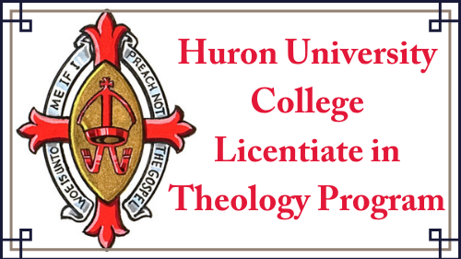

THIS COURSE HAS BEEN APPROVED
BY HURON’S FACULTY OF THEOLOGY COMMITTEE
FOR THE FALL TERM OF THE LTH PROGRAM, 2025.

