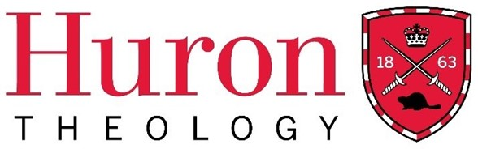

Winter Term 2025
The Licentiate in Theology Diploma Program

Theological Studies 340
The Life and Thought of Dietrich Bonhoeffer
Course Syllabus

Huron University College Land Acknowledgment

Huron is situated on the traditional lands of the Anishinaabeg, Haudenosaunee, Attawandaron, and Lenape peoples, whose sharing and stewardship of the land has been governed by the Dish with One Spoon treaty since time immemorial. We are guided by this treaty in the spirit of peace, friendship, and respect. Huron University College acknowledges its past role in perpetuating colonial and exclusionary relations. Because religious and ecclesial institutions were instrumental in such relations, we consider it our particular responsibility as a Faculty of Theology to work towards justice and reconciliation.

Course Dates: Hosted on Saturday February 15th and Saturday February 22nd, 2025
Time: Saturdays from 10 A.M – 3:30 P.M. (CT), 11 A.M. – 4:30 P.M. (ET)
Delivery: Hosted via Zoom
Instructor: Dr. Alex Michael Trew, Hon. BA (Cardiff Metropolitan University, UK); MTS (Regent College at the University of British Columbia); MA (Regent College, UBC); and PhD (University of Aberdeen, UK).
Contact: alexmichaeltrew@gmail.com

Course Description
Dietrich Bonhoeffer was a German pastor and academic recruited as a spy against the Nazi hierarchy during the Second World War and quickly caught up in a wider plot to assassinate Hitler. This course will introduce you to Bonhoeffer’s biography and three key dimensions of his theology, considering its development across his short life and how it shaped his decisions.
Course Objectives and Learning Outcomes
At the end of this course, students will:
- comprehend and be able to articulate the core components of Bonhoeffer’s theology.
- be familiar with the key events of Bonhoeffer’s life.
- be competent in reflecting on the value of theology for their own life and ministry.

Required Text(s)

Selections from Dietrich Bonhoeffer Works (English) assigned weekly.

Tietz, Christiane. Theologian of Resistance: The Life and Thought of Dietrich Bonhoeffer. Translated by Victoria Barnett. Minneapolis: Fortress Press, 2016.

Course Outline/Plan

Week 1

- Bonhoeffer in the Twenty-first Century

Reading:
- Bonhoeffer, Discipleship, 37-48.
- Stephen R. Haynes, The Battle for Bonhoeffer (Grand Rapids: Eerdmans, 2018), 1-11 (available through Google Drive).

Week 2

- ‘Christ-existing-as-community’, part 1

Readings:
- Bonhoeffer, Life Together, 27-47.
- Tietz, Theologian of Resistance, 1-12.

Week 3

- ‘Christ-existing-as-community’, part 2

Readings:
- Bonhoeffer, Life Together, 93-107.
- Tietz, Theologian of Resistance, 13-33.

Week 4

- The ‘man for others’, part 1

Readings:
- Bonhoeffer, Berlin 1932-1933, 300-308.
- Bonhoeffer, Discipleship, 84-91.
- Tietz, Theologian of Resistance, 35-52.

Week 5

- The ‘man for others’, part 2

Readings:
- Bonhoeffer, Ethics, 25-47.
- Tietz, Theologian of Resistance, 55-77.

Week 6

- ‘Religionless Christianity’, part 1

Readings:
- Bonhoeffer, Ethics, 1-24.
- Tietz, Theologian of Resistance, 81-110.

Week 7

- ‘Religionless Christianity’, part 2

Readings:
- Bonhoeffer, Letters and Papers from Prison (extracts from relevant letters).
- Tietz, Theologian of Resistance, 111-118.

Week 8

- Conclusion

Method of Evaluation and Criteria for Grading (only for students choosing to be evaluated for full course credit)

Two document studies (500 words each) and a Final Essay (1000 words) will be completed by each student seeking evaluation for full LTh credit.
1. Class Engagement/Participation – 20%
2. Reflective Report – 40%
3. Final Essay – 40%
[Examples] What have I learned in this course that I had not known before?
How do might I share the understandings within this course with my own congregational community?

Huron Grade Descriptors
A+ | 90-100 | One could scarcely expect better from a student at this level
A | 80-89 | Superior work which is clearly above average
B | 70-79 | Good work, meeting all requirements, and eminently satisfactory
C | 60-69 | Competent work, meeting requirements
D | 50-59 | Fair work, minimally acceptable
F | below 50 | Fail

Student Code of Conduct
Membership in the community of Huron University College and Western University implies acceptance by every student of the principle of respect for the rights, responsibilities, dignity and well-being of others and a readiness to support an environment conducive to the intellectual and personal growth of all who study, work, and live within it. Upon registration, students assume the responsibilities that such registration entails. While in the physical or online classroom, students are expected to behave in a manner that supports the learning environment of others. Please review the Student Code of Conduct at: https://huronatwestern.ca/sites/default/files/Res%20Life/Student%20Code%20of%20Conduct%20-%20Revised%20September%202019.pdf.

Statement on the Recording of Class Activities
Students may not record or distribute any class activity, including conversations during office hours, without written permission from the instructor, except as necessary as part of approved accommodations for students with disabilities. Any approved recordings may only be used for the student’s own private use.

Online courses within the Licentiate in Theology Program are recorded for student engagement purposes. These recording are only used by the registered students of the class and made available through a restricted video hosting site to respect both privacy and intellectual property. Should a student be uncomfortable with this practice, they can contact the course instructor or the LTh Program Director, Dr. Grayhame Bowcott at grayhame.bowcott@huron.uwo.ca

Support Services
For advice on course selections, degree requirements, and for assistance with requests for medical accommodation, students should contact the LTh Program Director, Dr. Grayhame Bowcott at grayhame.bowcott@huron.uwo.ca.

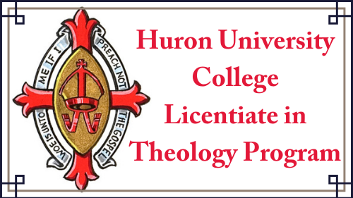

THIS COURSE HAS BEEN [NOT YET BEEN] APPROVED BY HURON’S FACULTY OF THEOLOGY COMMITTEE
FOR THE SPRING TERM OF THE LTH PROGRAM, 2025.

