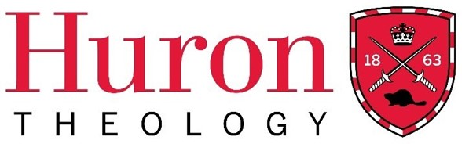

Fall Term 2025
The Licentiate in Theology Diploma Program

History of Religion 101 – The Early Church

Huron University College Land Acknowledgment

Huron is situated on the traditional lands of the Anishinaabeg, Haudenosaunee, Attawandaron, and Lenape peoples, whose sharing and stewardship of the land has been governed by the Dish with One Spoon treaty since time immemorial. We are guided by this treaty in the spirit of peace, friendship, and respect. Huron University College acknowledges its past role in perpetuating colonial and exclusionary relations. Because religious and ecclesial institutions were instrumental in such relations, we consider it our particular responsibility as a Faculty of Theology to work towards justice and reconciliation.

Course Dates: March 6, 13, 20, 27 and April 10, 24 (Winter Term 2025)
Time: Thursdays from 7 – 9 P.M. (CT), 8 – 10 P.M. (ET)
Delivery: Hosted via Zoom
Instructor: The Right Reverend William G. Cliff, M.Div, MA, DD
Contact: william.g.cliff@gmail.com

Course Description
This course will examine the early history of the Church through the lens of the theological and historical movements that gave the Church its shape and meaning in the first 600 years after Jesus. Rather than seeing the church’s development as a series of chronological dates and names, we will look at the texts of the early church using basic historical methods of document study. In so doing we will begin to see that the claims of Jesus’ followers and the communities they founded were shaped by the world around them, and affected the development of the language, theology, and the structure of the Church.

Required Texts and Study Documents

The Principal Texts/Documents for this course will be:
1) Henry Bettenson and ChrisMaunder ed., Documents of the Christian Church (fourth edition), New York: Oxford University Press, 2011.

2) Henry Chadwick, The Early Church (revised edition), London: Penguin Books, 1993

These are available on Amazon.ca and other sites such as abebooks.com

Please be sure to get the Fourth Edition of Bettenson and the Revised Edition of Chadwick.

Some short readings will be handed out in class and assigned from the following: Sean Freyne, The World of the New Testament, Wilmington, Delaware: Michael Glazier, 1980 William Placher and Derek Nelson, A History of Christian Theology, Louisville, Kentucky: Westminster John Knox Press 2013.

Course Outline/Plan

Week 1

- Locating the story in history - How to look at the documents that face us What is the historian’s job? How do texts help us? What tools will we use? a) historical background of 1st century Israel b) the social milieu and its way of thinking.

Week 2

- The Extra-biblical references to Jesus - a) Josephus, Pliny the younger, Suetonius, Tacitus and the Talmud b) The Biblical record of Jesus - Presentation of Jesus from Matthew, Mark, Luke and John differences and their implications for what follows.

Documents and Readings: Tacitus, Suetonius and Pliny the younger (Bettenson pgs 1-5) Chadwick (pgs 9-30).

Week 3

- Early Christology and Wrestling with God`s actions The Church develops its understanding of the nature of God - The Churches of Jerusalem, Antioch, Alexandria, Constantinople and Rome a) geography and preaching and teaching in the empire b) clashes of religiosity - divorce from the synagogue, persecution in the empire, apologists and, “secret knowledge” of Gnostics Eusebius, Justin Martyr, Tertullian, Iraneus, and the Shepherd of Hermas.
Documents and Readings: Persecutions and Apologists: (Bettenson Pgs 5-15) Chadwick: (pgs 32-73).

Week 4

- Early Christology and HERESY! Arians, Gnostics, Docetism, Donatism, Marcionism, Montanism, Manicheism and lots of other “isms” Understanding these movements in terms of where they were in the Empire, what they said about Jesus and why parts of the Church objected to what was being taught.

Documents and Readings: Heresies and ‘isms’: (Bettenson 37-47) Chadwick: Pages 74-115.

Week 5

- East and West - The Empire and the Papacy The Creeds and Councils Nicea, Constantinople, Ephesus and Chalcedon Church Ministry and Sacraments The Texts of the Creeds - Nicene and later Constantinopolitan clarifications

Documents and Readings: The Creeds (Bettenson 25-27) and other texts as supplied Church Ministry and Sacraments (Bettenson 66-81) Chadwick: Pages 116-159.

Week 6

- Consolidation of Authority in Rome Monasticism - East and West The Scriptures and Settling the Canon The Papacy as it is developing.

Documents and Readings: Chadwick: pages 174-236.

Method of Evaluation and Criteria for Grading (only for students choosing to be evaluated for full course credit)

COURSE ASSIGNMENTS:

Of all the Documents presented and read in this course, you will be asked to submit four (4) 500 word summaries of four (4) of the documents (or their excerpts) that we have discussed. Using you notes from class and your own notes from your readings (hint: make notes as you go) you should be able to summarize the importance of the document, why it was written, what great political, historical, theological or social problem is being addressed in the text and its significance in the history of the church.

Ask yourself what is being illustrated by the text as it is presented and what assumptions are
present. Some of these texts will be difficult to read because they are theological treatises, synodical documents or letters from correspondence, others will be foreign in their language or idiom. Look through that difficulty to the effect of the document, and write a summary of why it was written and why this document matters - what does it show us. If you have real difficulty in choosing 4 documents from this list, other documents may be offered as substitutes - but you may not have the benefit of the class discussion to help you write your summary or research your document.

Huron Grade Descriptors
A+ | 90-100 | One could scarcely expect better from a student at this level
A | 80-89 | Superior work which is clearly above average
B | 70-79 | Good work, meeting all requirements, and eminently satisfactory
C | 60-69 | Competent work, meeting requirements
D | 50-59 | Fair work, minimally acceptable
F | below 50 | Fail

Student Code of Conduct
Membership in the community of Huron University College and Western University implies acceptance by every student of the principle of respect for the rights, responsibilities, dignity and well-being of others and a readiness to support an environment conducive to the intellectual and personal growth of all who study, work, and live within it. Upon registration, students assume the responsibilities that such registration entails. While in the physical or online classroom, students are expected to behave in a manner that supports the learning environment of others. Please review the Student Code of Conduct at: https://huronatwestern.ca/sites/default/files/Res%20Life/Student%20Code%20of%20Conduct%20-%20Revised%20September%202019.pdf.

Statement on the Recording of Class Activities
Students may not record or distribute any class activity, including conversations during office hours, without written permission from the instructor, except as necessary as part of approved accommodations for students with disabilities. Any approved recordings may only be used for the student’s own private use.

Online courses within the Licentiate in Theology Program are recorded for student engagement purposes. These recording are only used by the registered students of the class and made available through a restricted video hosting site to respect both privacy and intellectual property. Should a student be uncomfortable with this practice, they can contact the course instructor or the LTh Program Director, Dr. Grayhame Bowcott at grayhame.bowcott@huron.uwo.ca

Support Services
For advice on course selections, degree requirements, and for assistance with requests for medical accommodation, students should contact the LTh Program Director, Dr. Grayhame Bowcott at grayhame.bowcott@huron.uwo.ca.

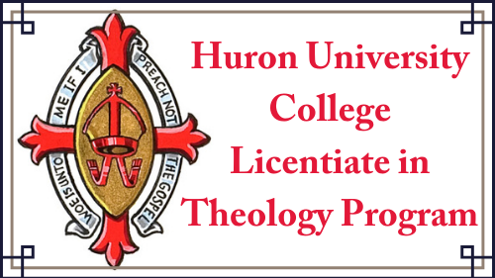

THIS COURSE HAS BEEN APPROVED BY HURON’S FACULTY OF THEOLOGY COMMITTEE
TO BE OFFERED IN THE WINTER/SPRING TERM OF THE LTH PROGRAM, 2025.

